**Name: Saloni Jain**

**Roll Number: 16CSU323**

**Date: 11th November, 2018**

***Graphical Dice Rolling Simulator***

**Code Fragment 1:**

import matplotlib.pyplot as plt

labels = ['1', '2', '3', '4','5','6']

sizes = [1,1,1,1,1,1]

colors = ['gold', 'yellowgreen', 'lightcoral', 'lightskyblue','pink','white']

explode = (0.1, 0.1, 0.1, 0.1, 0.1, 0.1)

plt.pie(sizes, explode=explode, labels=labels, colors=colors,

autopct='%1.1f%%', shadow=True, startangle=140)

plt.title('Frequency of Dice Numbers "Before" Rolling the Dice')

plt.axis('equal')

plt.show()

**Output 1:**

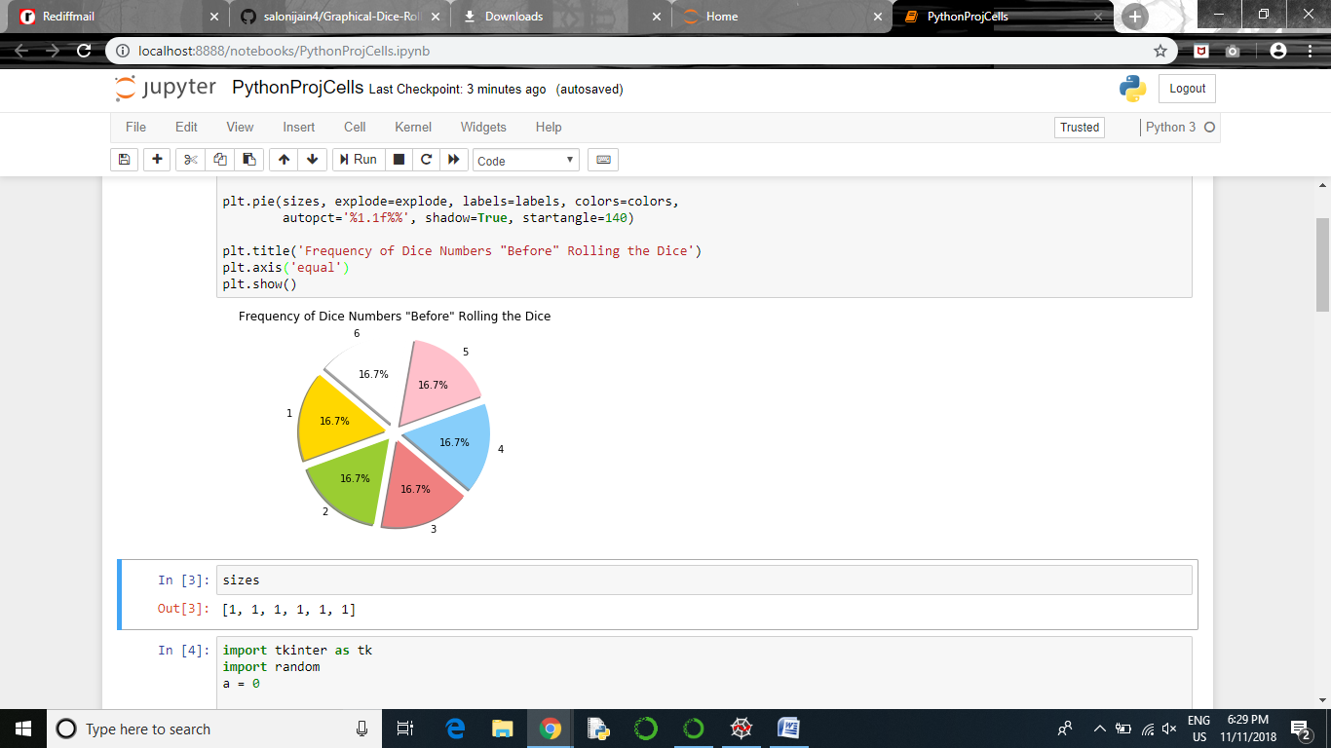

**Code Fragment 2:**

print(sizes)

**Output 2:**

[1, 1, 1, 1, 1, 1]

**Code Fragment 3:**

import tkinter as tk

import random

a = 0

def create_dice():

"""

create the dice canvas list as dice[0] to dice[6]

"""

dice = []

dice.append(draw_dice('dot0')) #empty

dice.append(draw_dice('dot5')) #center dot

dice.append(draw_dice('dot4', 'dot6'))

dice.append(draw_dice('dot3', 'dot5', 'dot7'))

dice.append(draw_dice('dot1', 'dot3', 'dot7', 'dot9'))

dice.append(draw_dice('dot1', 'dot3', 'dot5', 'dot7', 'dot9'))

dice.append(draw_dice('dot1', 'dot3', 'dot4', 'dot6', 'dot7', 'dot9'))

return dice

def draw_dice(*arg):

"""

draws the 7 different dice dots on the canvas

"""

w = 20

h = 20

c = tk.Canvas(root, width=w + 3, height=h + 3, bg='yellow')

#dot specifications

x = 2

y = 2

r = 5

if 'dot1' in arg:

dot1 = c.create_oval(x, y, x + r, y + r, fill='black')

x = w / 2

x = 18

if 'dot3' in arg:

dot3 = c.create_oval(x, y, x + r, y + r, fill='black')

x = 2

y = h / 2

if 'dot4' in arg:

dot4 = c.create_oval(x, y, x + r, y + r, fill='black')

x = w / 2

if 'dot5' in arg:

dot5 = c.create_oval(x, y, x + r, y + r, fill='black')

x = 18

if 'dot6' in arg:

dot6 = c.create_oval(x, y, x + r, y + r, fill='black')

x = 2

y = 18

if 'dot7' in arg:

dot7 = c.create_oval(x, y, x + r, y + r, fill='black')

x = w / 2

x = 18

if 'dot9' in arg:

dot9 = c.create_oval(x, y, x + r, y + r, fill='black')

if 'dot0' in arg:

pass

return c

def click():

"""

display a randomly selected dice value

"""

t = 100

stop = random.randint(13, 18)

a = stop % 6 - 1

sizes[a]+=1

for x in range(stop):

dice_index = x % 6 + 1

root.title(str(dice_index))

dice_list[dice_index].grid(row=1, column=0, pady=5)

root.update()

if x == stop - 1:

var1.set(str(x % 6 + 1))

break

root.after(t, dice_list[dice_index].grid_forget())

t += 25

root = tk.Tk()

var1 = tk.StringVar()

var1.set("")

result = tk.Label(root, textvariable=var1, fg='red')

result.grid(row=3, column=0, columnspan=3)

dice_list = create_dice()

dice_list[0].grid(row=1, column=0, pady=5)

button1 = tk.Button(root, text="Roll Dice", command=click)

button1.grid(row=2, column=0, pady=3)

root.mainloop()

**Output 3:**

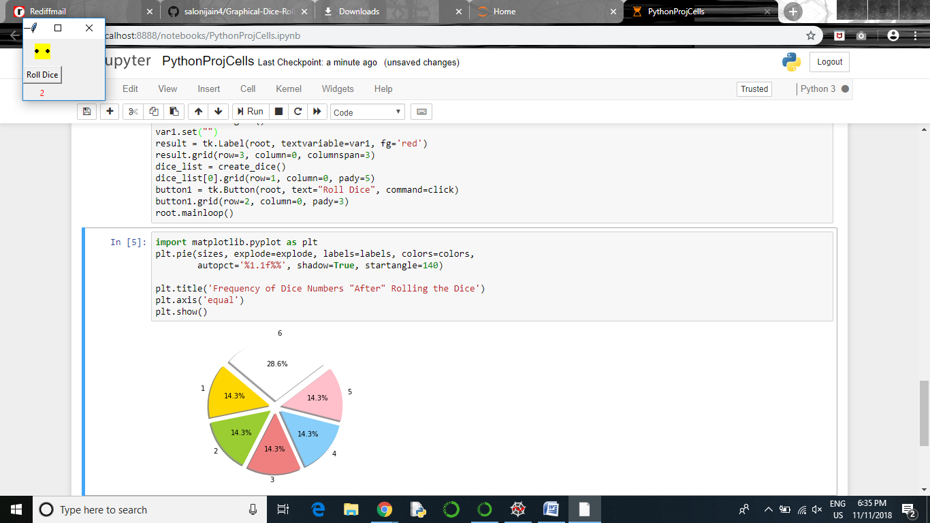

**Code Fragment 4:**

import matplotlib.pyplot as plt

plt.pie(sizes, explode=explode, labels=labels, colors=colors,

autopct='%1.1f%%', shadow=True, startangle=140)

plt.title('Frequency of Dice Numbers "After" Rolling the Dice')

plt.axis('equal')

plt.show()

**Output 4:**

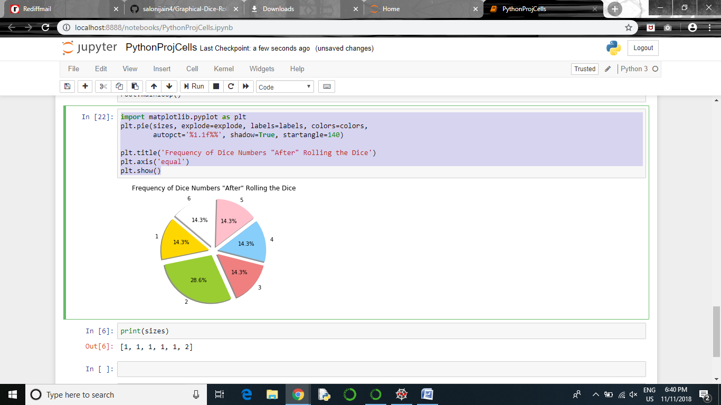

**Code Fragment 5:**

print(sizes)

**Output:**

[1, 2, 1, 1, 1, 1]